
Republic of the Philippines

COMMISSION ON AUDIT
Commonwealth Avenue, Quezon City, Philippines

CIRCULAR No. : 2002 – 002
Date: June 20, 2002

To : All Heads of National Government Agencies and All Others Concerned

Subject : Prescribing the Manual on the New Government Accounting System (Manual Version) For Use in All National Government Agencies

- Purpose

In line with COA Circular No. 2001-004 dated October 30, 2001, prescribing the New Government Accounting System (NGAS) in all national government agencies effective January 1, 2002, this manual on the NGAS (manual version) is hereby prescribed to ensure the proper accounting of all financial transactions of the National Government.

- The Manual on the NGAS

The NGAS Manual in its manual version is composed of three volumes, namely:

Volume I - The Accounting Policies

It shows the basic features and policies on NGAS, the government accounting plan, discussion on the financial statements and other related records required and the illustrative journal entries.

Volume II - The Accounting Books, Records, Forms and Reports

It contains the various formats of the books of accounts, registries, records, forms and reports including instructions on their use.

Volume III - The Chart of Accounts

It includes the list of accounts and the definitions/ descriptions of each account.

- Saving Clause

Cases not covered by this Circular shall be referred to the Office of the Chairman thru the Government Accounting and FMIS Office, this Commission, for resolution.

- Repealing Clause

This manual replaces the Government Accounting and Auditing Manual (GAAM), Volume II, prescribed under COA Circular No. 91-368, dated December 19, 1991.

Likewise, all other circulars, orders, memoranda and existing rules and regulations inconsistent with the provisions of this Manual are hereby amended/ modified/revoked accordingly.

- Effectivity Clause

This Circular shall take effect immediately.

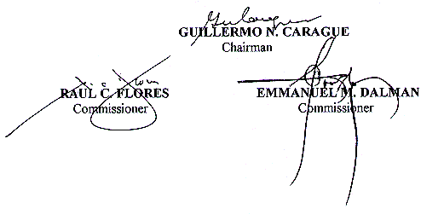

AcctcyO
FCO/MML/CBC
Circular 2002

